Style: Duns Tew (Cotswold) Tune: Fireworks, by Jeff Bigler Type: set/33“ (long) sticks with tosses Dancers: 6 Stepping: Duns Tew double-step, hockle-back, foot-together-jump Source: Jeff Bigler (1994) / Middlesex Morris (originally Fieldtown) Chorus: 4 plain capers into a circle. Toss/clash sequence: 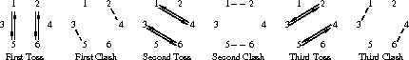
then foot-together-jump. “Explode” and return (3 double steps), all-in clash, galley, FTJ. Sequence: once to yourself, foot up, chorus, face-to-face, chorus, top-to-bottom, chorus, bottom-to-top, chorus, rounds & all-in

